CHAPTER 2
Trade-offs, Comparative Advantage, and the Market System
- Chapter Summary
- Learning Objectives
- Chapter Outline
Teaching Tips/Topics for Discussion
- Solved Problems
- Solutions to Review Questions and Problems and Applications

1. Chapter Summary
This chapter focuses on the concepts of scarcity and opportunity cost. The economic resources nations have to produce goods and services are scarce. The time available to households and firms is also scarce. Decision-makers face trade-offs as the result of scarcity. The model of the production possibilities frontier is used to analyze the opportunity costs and trade-offs that nations, firms and individuals face. The frontier is a curve that illustrates the combinations of two goods a nation can produce using all of its economic resources and a given state of technology, in a given time period. The production possibilities frontier leads to a general and key concept: The more resources that are devoted to an activity, the smaller the payoff to devoting additional resources to that activity. Production possibilities frontiers can be used to demonstrate the benefits to two individuals, or two nations, of specialization in production and trade.
Markets enable buyers and sellers of goods and services to come together to trade. The Circular Flow of Income shows how buyers (households) and sellers (firms) interact in both product and factor markets. Free markets exist when government places few restrictions on how a good or service can be produced and sold and how a factor of production can be employed.
Entrepreneurs, those who own and operate businesses, are critical to the working of a market system. They produce goods and services consumers want and decide how these goods and services should be produced to yield the most profit. Entrepreneurs organize factors of production and risk their own funds to start businesses. Successful entrepreneurs are rewarded for their efforts with profits, but many entrepreneurs, including many who later meet with success, suffer financial losses and business failures if they do not satisfy consumers’ wants. Although government does not restrict how firms produce and sell goods and services in a free market, it is essential that government protect rights to private property in order for a market system to work well.

2. Learning Objectives
Students should be able to:
- Use a production possibilities frontier to analyze opportunity costs and trade-offs.
- Understand comparative advantage and explain how it is the basis for trade.
- Explain the basic idea of how a market system works.

3. Chapter Outline
Managers Making Choices at BMW
1. The managers at firms such as BMW (the Bavarian Motor Works) must make decisions regarding the production and marketing of their products. These decisions include the location and relocation of manufacturing plants and the production methods used at these plants.
►Teaching Tips: The authors use BMW as an extended example in the chapter to explain the production possibilities frontier. An Inside Look at the end of the chapter uses the concepts of the chapter to analyze the performance of BMW during the first month of 2004. After you have gone through the chapter in class, ask your students to read An Inside Look as the basis for classroom discussion.
Production Possibilities Frontiers and Real-World Trade-offs
1. A graph of a linear production possibilities frontier (PPF) is used to illustrate the trade-off BMW faces in deciding how many Roadsters and SUVs it should produce given its limited resources and technology.
- A production possibilities frontier is a curve showing the maximum alternative combinations of two products that may be produced with available resources.
- The slope of a PPF is used to measure the opportunity cost of increasing the production of one good along the frontier.
- Opportunity cost is the highest-valued alternative that must be given up to engage in an activity.
  - The slope of a linear frontier, and the opportunity cost of moving along the frontier, is constant.
  - A convex or “bowed out” PPF illustrates increasing marginal opportunity costs.
  - Starting from the vertical intercept and moving downward along the convex frontier the slope of the PPF measures the ever-increasing opportunity cost of producing one unit of the good whose production is measured along the horizontal axis.
  - Economic growth will shift a PPF to the right.
  - Economic growth is the ability of the economy to produce increasing quantities of goods and services. Economic growth can occur if more resources become available or if a technological advancement makes resources more productive.
  - Growth may lead to greater increases in production for one good than another.
►Teaching Tips: Encourage students to use Solved Problem 2-1 to understand how frontiers illustrate opportunity costs and trade-offs. The PPF is the first of many graphs students will see in the textbook and many students will have initial difficulty measuring and understanding the slope of the frontier.
Refer to Making the Connection 2-1 for an explanation of the trade-offs charitable organizations face when aid solicited as a result of a natural disaster causes a reduction in their financial support. Students are likely to believe contributions to tsunami relief efforts are laudable but may have difficulty supporting these efforts if they are at the expense of homeless shelters or cancer research.
Trade
1. Specialization in production and trade allow individuals to enjoy a greater standard of living than would be possible if these individuals produced everything they consumed.
- Trade is the act of buying or selling.
- Mutually beneficial trade can be illustrated through a model in which two individuals produce the same two goods.
- PPFs depict the combinations of two goods that can be produced if no trade occurs.
- If one individual’s PPF shows greater production of both goods, this individual has an absolute advantage in producing both goods.
- Absolute advantage is the ability of an individual, firm, or country to produce more of a good or service than competitors using the same amount of resources.
- Each individual will have a comparative advantage in the production of one of the goods if the two individuals have different opportunity costs for producing each good.
- Comparative advantage is the ability of an individual, firm, or country to produce a good or service at a lower opportunity cost than other producers.
- Comparing the possible combinations of production and consumption before and after specialization and trade occur proves that trade is mutually beneficial.
►Teaching tips: Even good students have difficulty understanding comparative advantage. Assign Solved Problem 2-2 for homework. Students can be asked to explain the BEFORE TRADE and AFTER TRADE tables and the graphs in Step 3 to ensure their understanding of the problem. Encourage students to read the feature Don’t Let This Happen to You! to make sure they don’t confuse absolute and comparative advantage.

Instructors struggle to find examples of people who have had an absolute advantage in two different areas but still benefit from specialization. A good example of absolute advantage is Babe Ruth. Before he achieved his greatest fame as a home run hitter and outfielder with the New York Yankees, Ruth was a star pitcher with the Boston Red Sox. Ruth may have been the best left-handed pitcher in the American League during his years with Boston (1914-1919), but he was used more and more as a fielder in his last two years with the team. In fact, he established a record for home runs in a season (29) in 1919. The Yankees acquired Ruth in 1920 and made him a full-time outfielder. The opportunity cost of this decision for the Yankees was the wins he could have earned as a pitcher. But since New York already had skilled pitchers, the opportunity cost of replacing him as a pitcher was lower than the cost of replacing Ruth as a hitter. No one else on the Yankees could have hit 54 home runs, Ruth’s total in 1920; the next highest total was 11. It can be argued that Ruth had an absolute advantage as both a hitter and pitcher in 1920, but a comparative advantage only as a hitter.
The Market System
1. A market is a group of buyers and sellers of a good or service and the institution or arrangement by which they come together to trade.
- Product markets are markets for goods – such as computers – and services – such as medical treatment.
- Factor markets are markets for the factors of production, such as labor, capital, natural resources, and entrepreneurial ability.
- A circular-flow diagram is a model that illustrates how participants in markets are linked. The diagram demonstrates the interaction between firms and households in both product and factor markets.
2. A free market is a market with few government-imposed restrictions on how a good or service can be produced or sold, or on how a factor of production can be employed.
3. Entrepreneurs are an essential part of a market economy.
- An entrepreneur is someone who operates a business, bringing together the factors of production – labor, capital, and natural resources – in order to produce goods and services.
- Entrepreneurs often risk their own funds to start businesses and organize factors of production to produce those goods and services consumers want.
4. The role of government in a market system is limited but essential. Although government in a market economy imposes few restrictions on the choices made by consumers, resource owners and firms, government protection of private property rights is necessary for markets to operate efficiently.
- Property rights are the rights individuals or firms have to the exclusive use of their property, including the right to buy or sell it.
- New technology has created challenges to protection of property rights. Unauthorized copying of music and other intellectual property in cyberspace reduces the rewards to creativity and may reduce the amount of such activity in the future.
►Teaching tips: Students first learn scarcity at home, in school and in other non-market settings. In these environments, scarce items are often allocated by parents, teachers, or others who know those who receive these items. Fairness or equity is usually one allocation criterion. But in markets prices, not fairness, allocate scarcity. Students seldom know the identity of the people who produce the products they buy. The impersonal and decentralized character of markets is illustrated very well by the excerpt from “I, Pencil” found in Making Connection 2-2.

The role of government in a free market economy has often been compared to that of an umpire or referee in a sporting event. The most vocal critics of decisions made by these officials would not argue for their elimination. It would not take long for a tennis match or baseball game to turn into a shouting match (or worse!) if players were allowed to interpret the rules of their own games. On the other hand, the quality of sporting events suffers when officials bar players, coaches or managers from participating in contests for frivolous reasons.

Making the Connection 2-3 describes the difficulty of protecting property rights in cyberspace. To initiate class discussion, ask students these questions:
- How many of you have downloaded music via the Internet? (Or know someone who has?)
- Should the government have the right to grant exclusive rights to musicians and other artists to produce and sell their creative works?
- Should the government fine or prosecute individuals who illegally obtain music, books, movies, and other creative works in violation of property rights laws?

4. Solved Problems
The textbook includes Solved Problems to support Learning Objective 1 (Use a production possibilities frontier to analyze opportunity costs and trade-off) and Learning Objective 2 (Understand comparative advantage and explain how it is the basis for trade). Here is another Solved Problem that supports the third learning objective.

Solved Problem 2-3 Supports Learning Objective 2-3: Explain the basic idea of how a market system works.

Adam Smith’s “Invisible Hand”
Alan Krueger, an economist at Princeton University, has argued that Adam Smith “…worried that if merchants and manufacturers pursued their self-interest by seeking government regulation and privilege, the invisible hand would not work its magic…”
Source: Alan B. Krueger, “Rediscovering the Wealth of Nations,” New York Times, August 16, 2001.
- What types of regulation and privilege might merchants and manufacturers seek from the government?
- How might these regulations and privileges keep the invisible hand from working?

Solving the Problem:
Step 1: Review the chapter material. This problem concerns how goods and services are produced and sold and how factors of production are employed in a free market economic system as described by Adam Smith in An Inquiry into the Nature and Causes of the Wealth of Nations. You may want to review the section “The Gains from Free Markets,” which begins on page 48 of the textbook.
Step 2: Answer question (a) by noting the economic system in place in Europe in 1776. At the time, governments gave guilds – associations of producers – the authority to control production. The production controls limited the amount of output of goods such as shoes and clothing, as well as the number of producers of these items. Limiting production and competition led to higher prices and fewer choices for consumers. Instead of catering to the wants of consumers, producers sought the favor of government officials.
Step 3: Answer question (b) by contrasting the behavior of merchants and manufacturers under a guild system and a market system. The regulations ceded to guilds by government meant that producers did not have to respond to consumers’ demands for better quality, variety, and lower prices. Under a market system, producers who sell goods of poor quality at high prices suffer economic losses; producers who provide better quality goods at low prices are rewarded with profits. Therefore, it is in the self-interest of producers to address consumer wants. This is how the invisible hand works in a free market economy, but not in Europe in the 18th century.
5. Solutions to Review Questions and Problems and Applications

Answers to Thinking Critically Questions

1. Launching new products can have the benefit of higher sales, but these benefits must be weighed against the costs of launching the products.

2. The reason that goods are imported is that they can be produced at a lower cost in another country. Banning imports of BMWs may create some jobs in the U.S., but the price of the product will rise. In addition, such a ban on imports will probably provoke retaliation by other countries, which will restrict exports from the United States.

Answers to Review Questions

1. Scarcity is the situation in which wants exceed the limited resources available to fulfill those wants. There are some things which are available in such abundance that they exceed our wants. For example, for most people there is enough oxygen in the atmosphere that the amount they want to inhale equals or exceeds the amount available – so oxygen isn’t scarce for them. Another example might be weeds in your garden – unlike tomato plants, the amount available exceeds the amount you desire.

2. The production possibilities frontier is a curve showing all the attainable combinations of two products that may be produced with available resources. Combinations of goods that are on the frontier are efficient because all available resources are being fully utilized, and the fewest possible resources are being used to produce a given amount of output. Inefficiency is shown by points inside the production possibilities frontier, because the maximum output is not being obtained from the available resources. A production possibilities frontier will shift to the right if the amount of resources available for making the products rises or if technology improves so that we can make more output with the initial amount of inputs.

3. Increasing marginal opportunity costs means that as more and more of a product is made, the opportunity cost of making each additional unit rises. It occurs because the first units of a good are made with the resources that are best suited for making it, but as more and more is made, resources must be used that are best suited for producing something else. Increasing marginal opportunity costs implies that the production possibilities frontier is bowed to the right from the origin – that its slope gets steeper and steeper as you move down the production possibility frontier.

4. Absolute advantage is the ability to produce more of a good or service than competitors using the same amount of resources. Comparative advantage is the ability to produce a good or service at a lower opportunity cost than other producers. It is possible to have a comparative advantage in producing a good even if someone else has an absolute advantage in producing that good (and every other good). Unless the two producers have exactly the same opportunity costs of producing two goods – the same tradeoff between the two goods – one producer will have a comparative advantage in making one of the goods and the other producer will have a comparative advantage in making the other good.

5. The basis for trade is comparative advantage. If each party specializes in making the product in which it has the comparative advantage, they can arrange a trade that makes both of them better off. Each party will be able to obtain the product made by its trading partner at a lower opportunity cost than before.

6. The circular flow diagram illustrates how participants in markets are linked. It shows that in factor markets, households supply labor and other inputs to production in exchange for wages and other payments from firms. In product markets, households use the payments they earn in factor markets to purchase the goods and services produced by firms.

7. The two main categories of market participants are households and firms. Households as consumers are the most important in determining what goods and services are produced. If they don’t want to buy something, there is no reason for the firms to make it.

8. A free market is one with few government restrictions on how goods or services can be produced or sold, or on how factors of production can be employed. Economic decisions are made by buyers and sellers in the market place. In a command economy, the government – rather than households and firms – makes almost all the economic decisions. Free market economies have a much better track record of providing people with rising standards of living.

9. An entrepreneur operates a business. Entrepreneurs play a key role in the economy by bringing together the factors of production – labor, capital, and natural resources – to produce goods and services for sale. Entrepreneurs decide what to produce and how to produce it. They put their own funds or borrowed funds at risk when they start a business.

10. Firms are likely to produce more of a good or service if consumers want more of it. As consumer demand rises, price will rise, which will induce firms to produce more. If demand falls, price will fall, firms will have less reason to produce the good and will cut back production.

11. Private property rights are the rights individuals or firms have to the exclusive use of their property, including the right to buy or sell it. If individuals and firms believe that property rights are insecure, they will be unwilling to produce goods or services or pay others to produce goods or services. Thus, the enforcement of property rights and contracts is vital for the functioning of the economy. Independent courts are crucial because property rights and contracts will only be enforced if judges make impartial decisions based on the law, rather than partial decisions in favor of powerful or politically-connected individuals.

Answers to End-of-Chapter Problems and Applications

1. a. The production possibilities frontiers in the figure are bowed to the right from the origin because of increasing marginal opportunity costs. The drought causes the production possibilities frontier to shift to the left.
b. The genetic modifications would shift to the right the maximum soybean production (doubling it), but not the maximum cotton production.

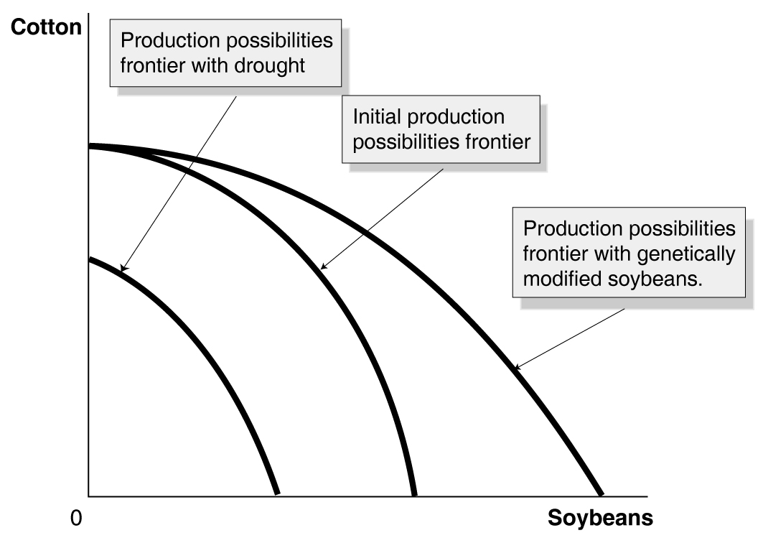

2. Increased safety will decrease gas mileage, as shown in the figure. Tradeoffs can be between physical goods, such as cotton and soybeans in problem 1, or between less tangible things like mileage and safety.

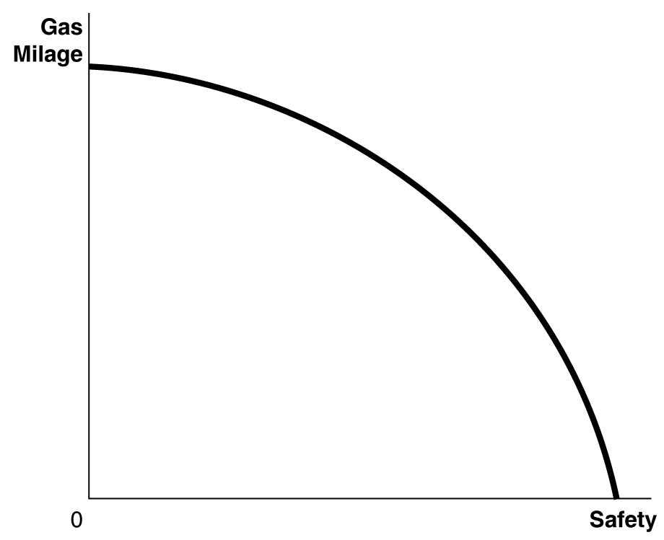

3. You would still have an opportunity cost represented by the next best use of your time.

4. a. The production possibility frontier will be concave like Figure 2-2 because some economic inputs are likely to be more productive when making capital goods, and others are likely to be more productive when making consumption goods.

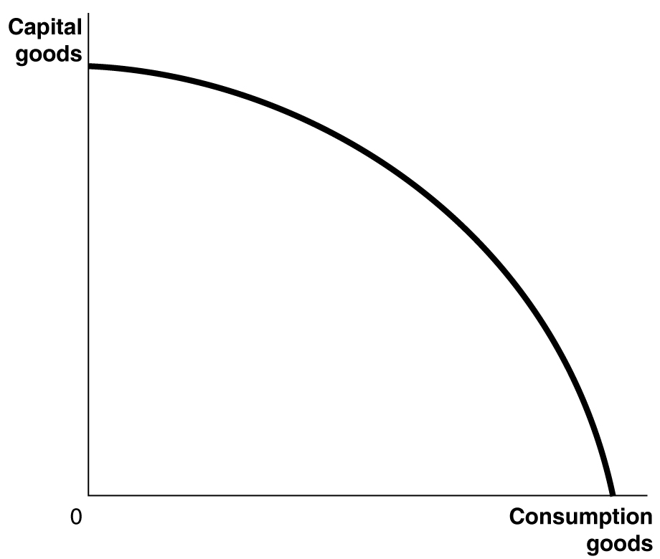

b.

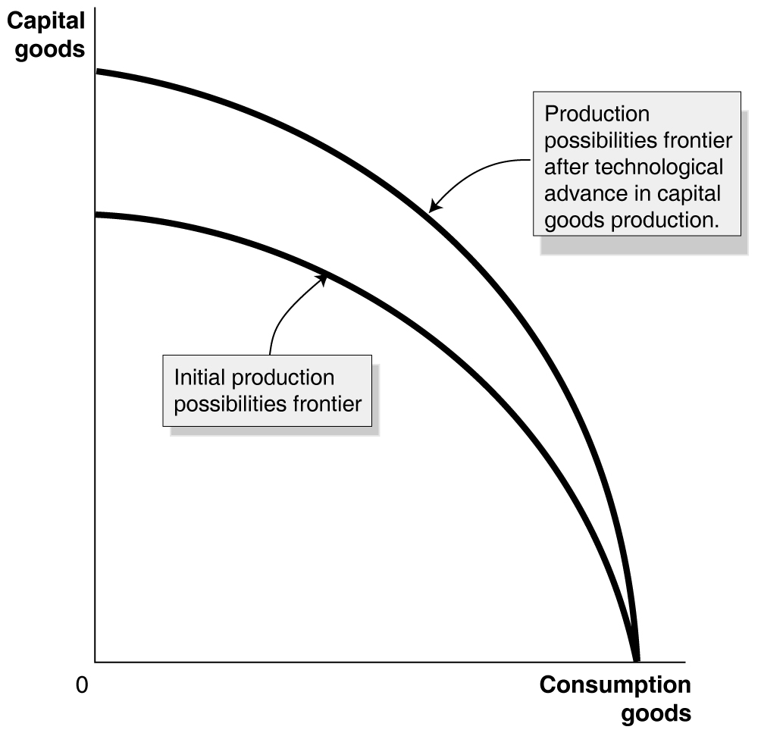

c. Because it will have more machinery and equipment, Country B is likely to experience more rapid growth.

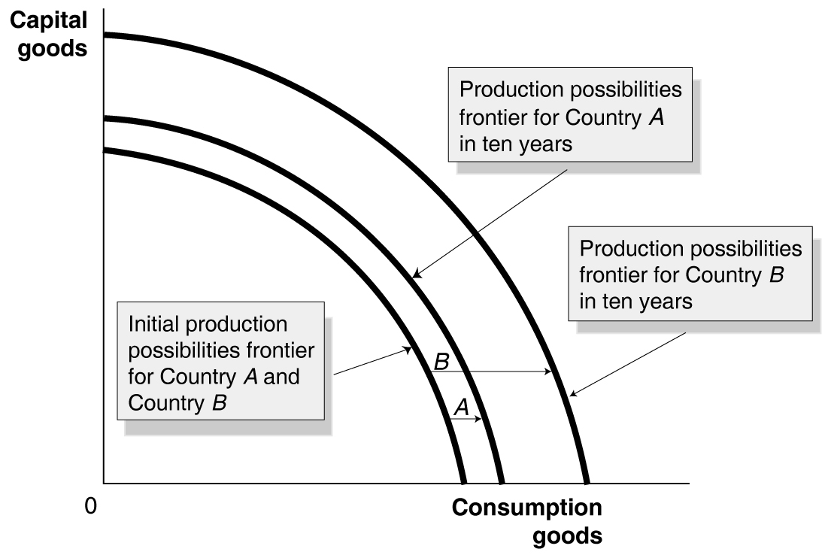

5. a. Point E is outside the production possibility frontier, so it is unattainable.
b. Points B, C, and D are on the production possibility frontier, so they are efficient.
c. Point A is inside the production possibility frontier, so it is inefficient.
d. At point B, the country is devoting the most resources to producing capital goods, so production at this point is most likely to lead to the highest growth rate.

6. a.

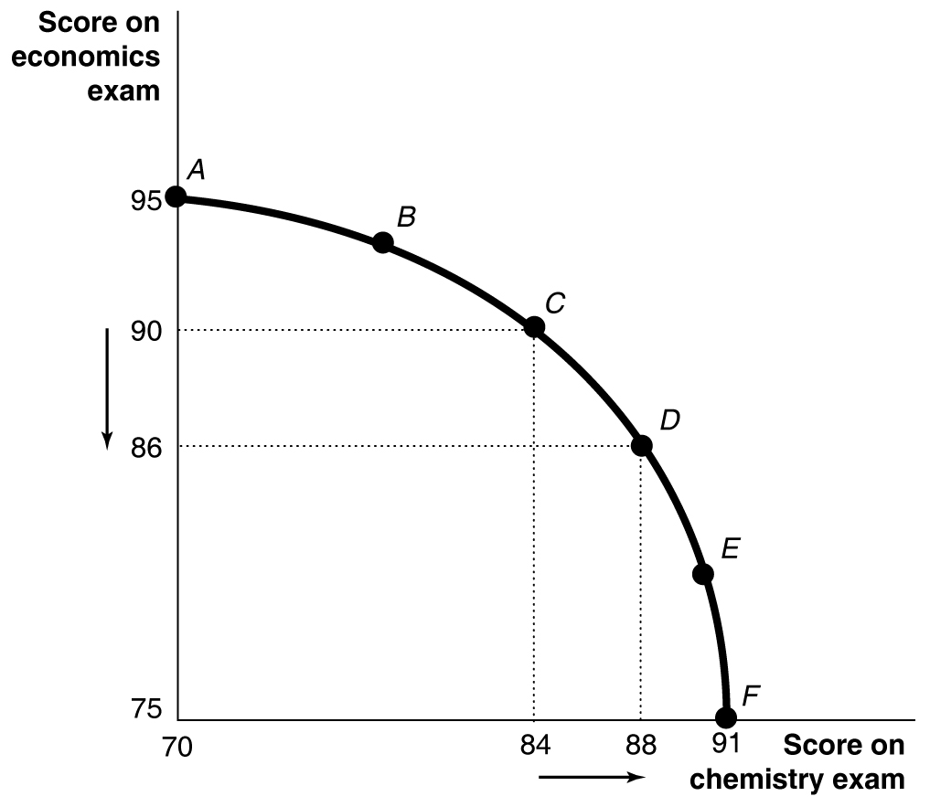

b. The opportunity cost of increasing your chemistry score by 4 points in moving from Choice C to Choice D is the 4 point decline in your economics score.
c. Choice A might be sensible if the marginal benefits of doing well on the chemistry exam are low relative to the marginal benefits from doing well on the economics exam – for example, the chemistry exam is only a small portion of your grade, but the econ exam is a large portion of your grade; or if your are majoring in economics and don’t care much about chemistry; or if you already have an A sewn up in chemistry, but the econ professor will replace a low exam grade with this exam grade.

7. If the federal government has a fixed budget for medical research, then the opportunity cost of funding more research on heart disease is the reduction in funding for research on other diseases. The decision should be made at the margin: to maximize the benefits from government spending on medical research, the last dollar devoted to research on heart disease should result in the same marginal benefit – less disease and fewer deaths – as the last dollar spent on research for other diseases. If the additional funding for research on heart disease comes at the expense of other non-medical research expenditures, then the opportunity cost will change, but a similar analysis should be conducted.

8. Most economists would argue that unless the costs of complying with environmental regulations are taken into account, society runs the risk of devoting too many resources to improving the environment compared with other goals. By ordering the EPA to ignore costs, Congress was forcing the EPA to approve regulations that it would not have approved if costs were taken into account. The decision to tell the EPA to ignore costs may have been a foolish mistake or a way of seeming very friendly to the environment to people who don’t think about the opportunity cost of reducing air pollution.

9. Resources used to reduce pollution are not available for other uses, such as saving lives via medical research, so it is moral to consider their opportunity cost.

10. Economic systems that do not allow people to keep most of the output they produce do not provide much incentive for people to work hard. Unfortunately, experience has shown that people are more self-interested and less altruistic than would be necessary for the system used in Oz to work in the real world.

11. a. Canada has the comparative advantage in making boots. Canada’s opportunity cost of making one boot is giving up one shirt. In the U.S., the opportunity cost of making one boot is giving up three shirts. The U.S. has the comparative advantage in making shirts. In the U.S., the opportunity cost of making one shirt is giving up one-third of a boot, but Canada’s opportunity cost of making one shirt is one boot.
b. Neither country has an absolute advantage in making both goods. The U.S. has the absolute advantage in shirts, but Canada has the absolute advantage in boots.
c. If both countries specialize in the good in which they have a comparative advantage and then trade with the other, they can both be better off. Let’s use the case in which each trades half of what it makes for half of what the other makes. The U.S. will specialize by making 12 shirts and Canada will specialize by making 6 boots. Since each gets half of the other’s production, they both end up with 6 shirts and 3 boots. This means they are better off than before trading, since they end up with the same amount of boots, but twice as many shirts. Others trades will make them better off, as well.

12. a. Neither country has a comparative advantage in either good. In both countries, the opportunity cost of one barrel of oil is one barrel of olive oil. Comparative advantage only arises if someone has a lower opportunity cost, but these two countries have the same opportunity cost.
b. No, the countries can’t gain from trade. Trading across the border gives the same tradeoffs that can be made within each country.

13. a. France has the comparative advantage in making wine. France’s opportunity cost of making one bottle of wine is giving up two pounds of schnitzel. In Germany, the opportunity cost of making one bottle of wine is giving up three pounds of schnitzel – so its opportunity cost for making wine is higher and France has the lower opportunity cost (and hence the comparative advantage) for making wine. Germany has the comparative in making schnitzel. In Germany, the opportunity cost of making one pound of schnitzel is giving up one-third of a bottle of wine. France’s opportunity cost of making one pound of schnitzel is one-half of a bottle of wine. Germany’s opportunity cost of schnitzel is lower, so it has the comparative advantage in schnitzel.
b. If they both specialize in the good in which they have the comparative advantage, France will make 4 bottles of wine and Germany will make 15 pounds of schnitzel. France could trade 3 bottles of wine to Germany for 7 pounds of schnitzel. This will give France the same amount of wine as initially, but an extra 1 pound of schnitzel. Germany will have 3 bottles of wine and 8 pounds of schnitzel – i.e., the same amount of wine, but more schnitzel. Other trades will make them better off, as well.

14. Yes, the United States would have benefited from importing those products where Britain had a comparative advantage.

15. a. An auto purchase takes place in the product market. The household (George) demands the good and the firm (BMW) supplies the good.
b. The labor market is a factor market. The households supply the labor and the firm demands the labor.
c. This is a factor market. The household (George) supplies the factor of production (labor), while the firm (McDonald’s) demands it.
d. The land market is a factor market. The household supplies the factor of production and the firm demands it.

16. Adam Smith was making the “invisible hand” argument that, in pursuing their self-interest, business people end up producing the goods and services most desired by consumers.

17. The invisible hand is the basic market mechanism. Understanding it is fundamental to all economic analysis.

18. Adam Smith realized – as economists today realize – that people’s motives can be complex. But in analyzing people in the act of buying and selling, economists have concluded that in most instances, the motivation of financial reward provides the best explanation for the actions people take. Moreover, being self-interested – looking out for your own well-being and happiness – and being selfish – caring only about yourself – are not exactly the same things. Many successful business people are, in fact, generous: donating to charity, volunteering for activities, and otherwise acting in a generous way. This is not inconsistent with making business decisions that maximize profits for their companies.

19. Whether self-interest is an “ignoble human trait” is a matter of opinion. There are certainly more noble traits than self-interest, but without at least some self-interest, a person wouldn’t survive. A market system encourages self-interest in the sense that it paradoxically allows people to enrich themselves by fulfilling the needs of others; that is, by producing goods and services that fulfill the wants of consumers.

20. Most economists would agree that this is a good basis to judge an economy. It’s hard to disagree with respect to developing countries, where many people live in abject poverty and standards of living are low. It’s easier to disagree if everyone in a society has a very high standard of living, but has to give up a lot to get it, by, say, working long hours. Any debate would probably center on what is meant by the “standard of living.”

21. Having secure property rights would enable the owners to use their resources in more efficient ways, because they would spend less time on activities such as guarding their property. Owners would also be able to make improvements to their property without fear that someone would seize the property. They would also be more likely to be able to use their property as collateral for a loan. This is exactly what occurred, according to the article in the New York Times.

22. Falling transportation costs allowed people to trade more easily and to specialize on the basis of their comparative advantage.

23. Importing only products that could not be produced here would result in the United States producing – rather than importing – many goods for which it does not have a comparative advantage. These products would be produced at a higher opportunity cost than if they had been imported.

